|  |
| --- |
| **ESCUELA SECUNDARIA NO. 100 "LUIS DE CAMOENS" 2021-2022**  **ACTIVIDAD A REALIZARSE DE LA SEMANA DEL 6 AL 17 DE DICIEMBRE 2021** |

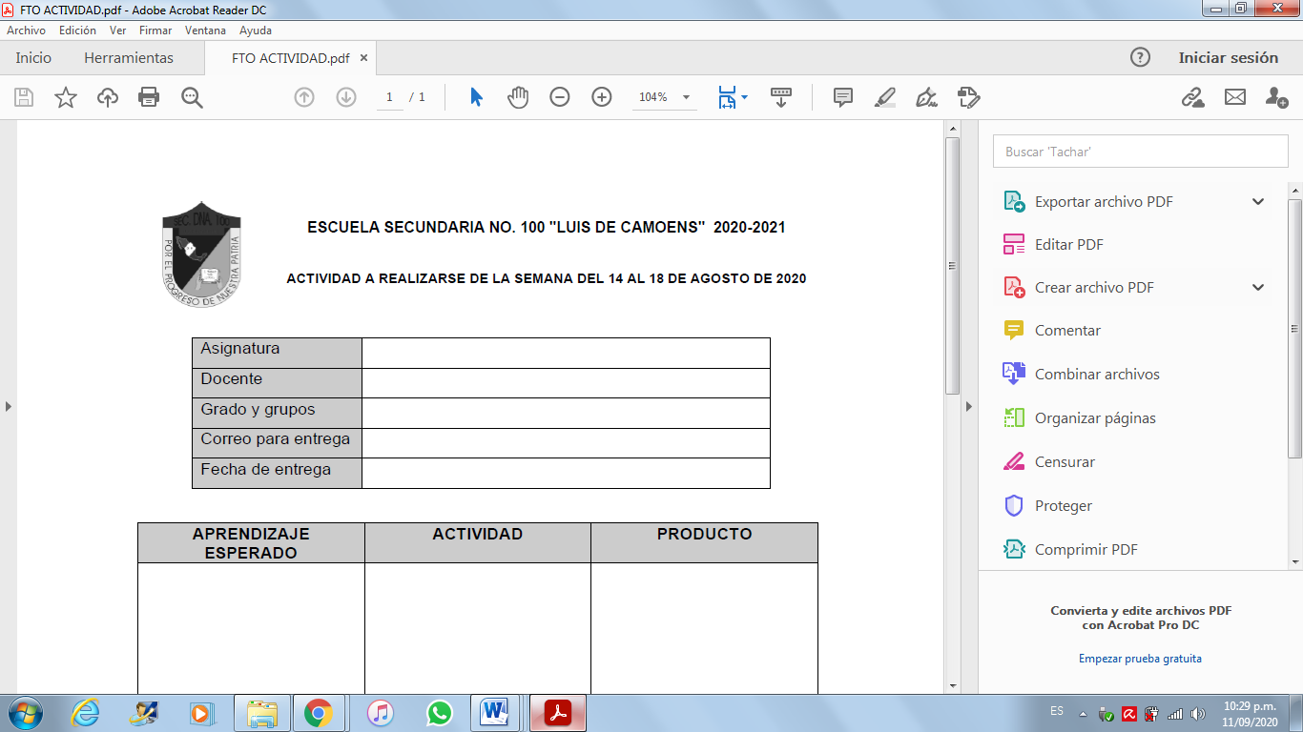

|  |  |
| --- | --- |
| **ASIGNATURA** | **Lengua Extranjera Inglés** |
| **DOCENTE** | **GUZMÁN Becerril Luis Fernando** |
| **GRADO Y GRUPOS** | **3º A, B, C, D, E, F** |
| **MEDIO POR EL CUAL RECIBIRÁ LAS ACTIVIDADES.** | Correo electronico institucional  luis.guzmanb@aefcm.gob.mx |
| **FECHA DE ENTREGA** | **DICIEMBRE 17, 2021** |
| **APRENDIZAJE ESPERADO** | **ACTIVIDAD** | **PRODUCTO** |
| Entendemos y razonamos en el tema de competitividad | 1.- Traduce el siguiente texto  U.S. Competitiveness: The Education Imperative  BY [BART GORDON](https://issues.org/byline/bart-gordon)  *Because the foundation for future success is a well-educated workforce, the necessary first step in any competitiveness agenda is to improve science and mathematics education.*  U.S. competitiveness and the country’s standing among our global counterparts have been persistent issues in public policy debates for the past 20 years. Most recently they have come to prominence with the publication of reports from the National Academies, the Electronics Industries Alliance, and the Council on Competitiveness, each of which argues that the United States is in danger of losing out in the economic competition of the 21st century.  There is no single cause for the concerns being raised, and there is no single policy prescription available to address them. However, there is widespread agreement that one necessary condition for ensuring future economic success and a sustained high standard of living for our citizens is an education system that provides each of them with a solid grounding in math and science and prepares students to succeed in science and engineering careers.  Unless the United States maintains its edge in innovation, which is founded on a well-trained creative workforce, the best jobs may soon be found overseas. If current trends continue, along with a lack of action, today’s children may grow up with a lower standard of living than their parents. Providing high-quality jobs for hard-working Americans must be our first priority. Indeed, it should be the central goal of any policy in Congress to advance U.S. competitiveness.  The United States is in direct competition with countries that recognize the importance of developing their human resources. The numbers and quality of scientists and engineers being educated elsewhere, notably in China and India, continue to increase, and the capabilities of broadband communications networks make access to scientific and engineering talent possible wherever it exists. The result is that U.S. scientists and engineers must compete against their counterparts in other countries, where living standards and wages are often well below those of the United States. Policies for maintaining U.S. competitiveness must consider how to ensure that U.S. scientists and engineers are educated to have the skills and abilities that will be in demand by industry and will allow them to command salaries that will sustain our current living standards.  Because the foundation for future success is a well-educated workforce, the necessary first step in any competitiveness agenda is to improve science and mathematics education. Unfortunately, all indications are that the United States has some distance to go in preparing students for academic success in college-level courses in science, mathematics, and engineering. Current data show that U.S. students seem to be less prepared than their foreign contemporaries.  The National Assessment of Educational Progress (NAEP), often referred to as the nation’s report card, has tracked the academic performance of U.S. students for the past 35 years. Achievement levels are set at the basic (partial mastery of the knowledge and skills needed to perform proficiently at each grade level), proficient, and advanced levels. Although student performance in mathematics improved between 1990 and 2000, most students do not perform at the proficient level. In the NAEP assessment for grades 4 and 8 in 2003 and for grade 12 in 2000, only about one-third of 4thand 8th-grade students and 16% of 12th-grade students reached the proficient level.  In science, progress has also been slow. Between 1996 and 2000, average NAEP science scores for grades 4 and 8 did not change, and grade 12 scores declined. For grades 4 and 8 in 2000, only about one-third of 4th- and 8th-grade students achieved the proficient level, and only 18% achieved that level by grade 12.  The United States also fares poorly in international comparisons of student performance in science and mathematics, such as the Program for International Student Assessment (PISA), which is coordinated by the Organization for Economic Cooperation and Development (OECD). PISA focuses on the reading, mathematics, and science capabilities of 15-year-olds and seeks to assess how well students apply their knowledge and skills to problems they may encounter outside of a classroom. In the recently released 2003 PISA results, U.S. students, compared with contemporaries in 49 industrial countries, ranked 19th in science and 24th in mathematics. U.S. students’ average science scores did not change from the first PISA assessment in 2000, whereas student scores increased in several OECD countries. Consequently, the relative position of U.S. students declined as compared with the OECD average.  A separate set of international comparisons—the Third International Mathematics and Science Study (TIMSS)— tracked the performance of students in three age groups from 45 countries. Although U.S. 4th-grade students performed quite well (above the international average in both mathematics and science), by the 8th grade, U.S. students scored only slightly above the international average in science and below the average in mathematics. By the 12th grade, U.S. students dropped to the bottom, outperforming only Cyprus and South Africa. The TIMSS results suggest that U.S. students actually do worse in science and mathematics comparisons the longer they stay in school. | Traduce un texto |

Evaluación:

|  |  |  |  |  |
| --- | --- | --- | --- | --- |
| CATEGORIA | MUY ALTO (10 ó 9) | ALTO (8) | BÁSICO (7) | BAJO (6 ó 5) |
| ORGANIZACIÓN | El contenudo y presentación estan bien organizados usando titulos y bien agrupado. | El contenido y presentación estan bien organizados pero presenta puntos debiles. | La mayor parte del contenido esta organizado lógicamente. | La organización del trabajo no fue clara y falta lógica, se limito a entregar. |
| CREATIVIDAD | La presentación y el trabajo manual demuestran gran originalidad e ingeniosidad. | Muestra cierta originalidad en cuanto al uso de material e ideas. | Usa ideas de otros trabajos y casi no hay evidencia de originalidad. | Usa ideas de otras personas y no les da credito. |
| INFORMACIÓN | Aborda el tema con profundidad, brinda detalles y ejemplos. El desempeño es excelente. | Incluye conocimiento básico del tema, el contenido en general es bueno. | Incluye información esencial del tema pero presenta errores. | La calidad en la información es minima y tiene varios errores |